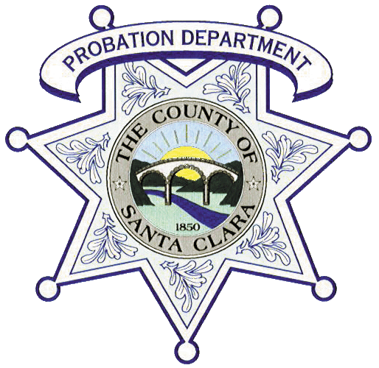
SANTA CLARA COUNTY PROBATION DEPARTMENT

Juvenile Hall
Extra-Help Group Counselor I
Application Packet
Group Counselor I – Required Documents:
County of Santa Clara Job Application
Social Security Card
Official High School and College Transcripts for All Institutions Attended): 60 Semester or 90 Quarter Units (sealed)
Current California Driver’s License
Current DMV Driver's License Driving Record (INF 1125) dated within 30 days from date of submission
Proof of Current Auto Insurance Coverage (applicant must be listed as the insured)
Adult/Child/Infant CPR and First Aid Card (on-line certifications will not be accepted)
Personal History Statement (completed and dated within 30 days from submission date)
* Qualified applicants must successfully pass a complete background investigation, including fingerprints, polygraph exam, a psychological evaluation, and a medical exam.
Disqualifications:
- Any conviction with elements of violence
- Under the age of 21

Applications and documents must be personally delivered by the applicant. Do not mail!
Please call to schedule an interview only after you have completed all paperwork and have possession of the required documents listed above!
Juvenile Hall Supervising Group Counselor:
Marco Diaz (408) 278-5962

APPLICANT: |  |  |  |  | CLASSIFICATION: |  | Extra-Help  Group Counselor I
SUBMITTED BY: |  |  |  |  | DATE:
 |  | Supervising Group Counselor
CLEARED BACKGOUND: |  |  |  |  | DATE:
 |  |  |  | Background Analyst
APPROVED FOR HIRE: |  |  |  |  | DATE:
 |  |  | Personnel Manager

