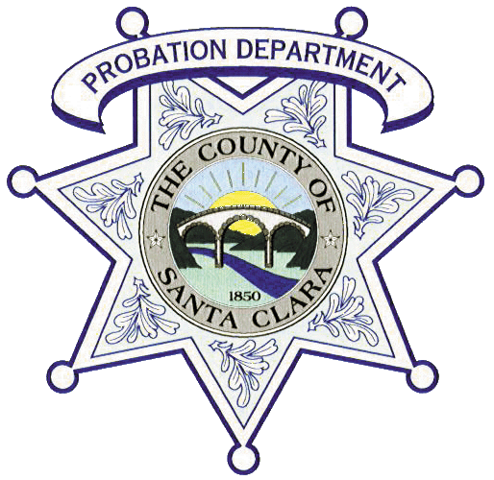
SANTA CLARA COUNTY PROBATION DEPARTMENT

James Ranch
Extra-Help Probation Counselor I, Probation Assistant I
Application Packet
Probation Counselor I – Required Documents:
County of Santa Clara Job Application
Social Security Card
High School Diploma – Official Transcript (sealed)
Bachelor’s Degree – Official Transcripts for All Colleges Attended (sealed)
Current California Driver’s License
Current DMV Driver's License Driving Record (INF 1125) dated within 30 days from date of submission
Proof of Current Auto Insurance Coverage (applicant must be listed as the insured)
Adult/Child/Infant CPR and First Aid Card (on-line certifications will not be accepted)
Personal History Statement (completed and dated within 30 days from submission date)
Probation Assistant I – Required Documents:
County of Santa Clara Job Application
Social Security Card
Official High School and College Transcripts for All Institutions Attended): 60 Semester or 90 Quarter Units (sealed)
Current California Driver’s License
Current DMV Driver's License Driving Record (INF 1125) dated within 30 days from date of submission
Proof of Current Auto Insurance Coverage (applicant must be listed as the insured)
Adult/Child/Infant CPR and First Aid Card (on-line certifications will not be accepted)
Personal History Statement – Peace Officer (completed and dated within 30 days from submission date)

* Qualified applicants must successfully pass a complete background investigation, including fingerprints, a psychological evaluation, and a medical exam.
Disqualifications:
- Any conviction with elements of violence
- Under the age of 21

Applications and documents must be personally delivered by the applicant. Do not mail!
Please call to schedule an interview only after you have completed all paperwork and have possession of the required documents listed above!
William F. James Boys’ Ranch
19050 Malaguerra Avenue
Morgan Hill, CA 95037
Supervising Probation Counselor:
Edgar Hernandez (408) 201-7600

APPLICANT: |  |  |  |  | CLASSIFICATION: |  | Extra-Help  Probation Counselor  Probation Assistant
SUBMITTED BY: |  |  |  |  | DATE:
 |  | PM or Supervising Probation Counselor
CLEARED BACKGOUND: |  |  |  |  | DATE:
 |  |  |  | Background Analyst
APPROVED FOR HIRE: |  |  |  |  | DATE:
 |  |  | Personnel Manager

